Directions: The goal of the following problems is to help challenge and deepen your understanding of the current topic. Don’t assume that you will know how to answer each and every question. You will work with at least two other students in the class to try and find solutions and write arguments for each of the following questions. Be sure that you question your classmates’ reasoning. If you don’t understand how they are getting something you should ASK THEM TO EXPLAIN! Being able to defend your reasoning is important and so you are actually helping them by asking them to explain.

Challenge Questions

- Find the equation of the line tangent to the given curve at the point .

Therefore, the slope of the tangent line is given by

Thus, the equation of the tangent line is .

- True or False? The tangent line to the function (shown below) is horizontal when .
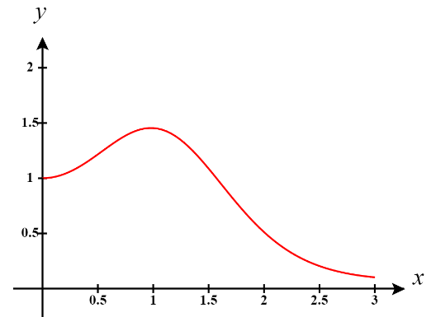
FALSE

We note that
Then

This means that when ,
The only way this could equal 0 (and therefore imply a horizontal tangent line when is if . However, note that and . Therefore, there is no way that could equal and thus and does NOT have a horizontal tangent line when

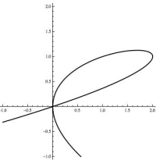
- The following is the graph of . There are two points on the graph where . Determine the equation of both tangent lines to the graph where .

We note that has a y-value of 1 when
.

We calculate:

We then find that for each line we have the following:
Point:  Slope:  Equation: | Point:  Slope:  We must have a line that if vertical and passes through  Equation:
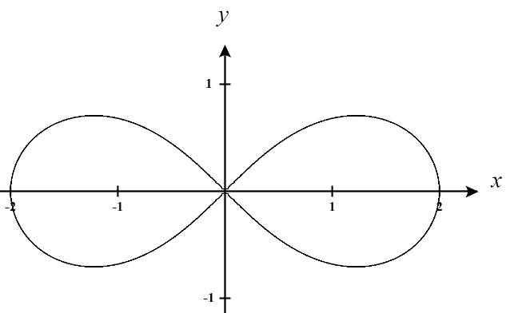
- The lemniscate shown below is described by the equation and is used in typography to denote infinity
- Find for points on the graph.

- Are there any points on the curve for which is undefined? If so, find all such points.

Yes. If then is undefined. Therefore, any point of the form results in being undefined.

Note that if then is positive regardless of the value of x and thus cannot equal 0.
Note that if then is negative regardless of the value of x and thus cannot equal 0.

- Determine the equation for the tangent line at the point

Point:
Slope:
Equation:

- Consider a circle centered at the origin with radius r.

- If , show that the tangent line at the point is perpendicular to the radius of the circle.

Our plan will be to first find the slope of the tangent line at P and then determine the slope of the radius of the circle when it is touching P. These slopes should be opposite, reciprocal values if the tangent line if perpendicular to the radius.

First, we find the tangent line at P.
The equation of the circle is given by .
Therefore, slope of any tangent line on this curve is given by
So, the slope of the tangent line at is

Second, we find the slope of the radius that connects the origin to .
.

Clearly these slopes are opposite reciprocals and therefore the tangent line at is perpendicular to the radius of the circle at this point.

- Show that for a circle of any radius that the tangent line at the point is perpendicular to the radius of the circle.

We enact the same strategy as in part (a).

First, we find the tangent line at P.
The equation of the circle is given by .
Therefore, slope of any tangent line on this curve is given by

Second, we find the slope of the radius that connects the origin to .
.

Clearly these slopes are opposite reciprocals and therefore the tangent line at is perpendicular to the radius of the circle at any point.

